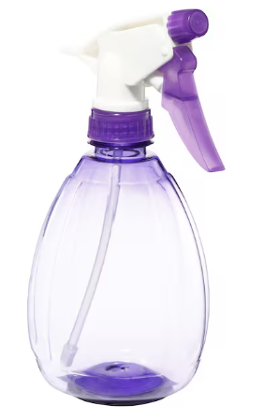
Instructions:
Find your picture & insert.
Select picture.
Right click. Go to: Text wrap
Selected “Infront of text”
Resize picture to fit into outline

